Лабораторна робота № 1
Тема: Класи й об'єкти в C++ та C#.
Мета роботи: Одержати навички реалізації класів на С++ та C#.

Виконання роботи
Завдання 1:
10.ЦЕХ
ім'я- char*
начальник – char*
кількість працюючих- int

Код програми:
на С++
файл Ceh.h
#pragma once
class Ceh
{
private:
char name[30];
char director[30];
int workers;

public:
Ceh();
Ceh(const char* name, const char* director, int workers);
Ceh(const Ceh&);
~Ceh();

char* getName();
char* getDirector();
int getWorkersCount();

void setName(const char*);
void setDirector(const char*);
void setWorkerCount(int);

void showAllParams();
};
Файл Ceh.cpp
#include "Ceh.h"
#include <iostream>
using namespace std;
Ceh::Ceh() :name(""), director(""), workers(0) {
cout << "simple create\n";
}
Ceh::Ceh(const char* name, const char* director, int workers) {
cout << "Constructor with params\n";
strcpy_s(this->name, name);
strcpy_s(this->director, director);
this->workers = workers;
}

Ceh::Ceh(const Ceh& ceh) {
cout << "Construct-copy\n";
strcpy_s(this->name, ceh.name);
strcpy_s(this->director, ceh.director);
this->workers = ceh.workers;
}
Ceh::~Ceh() {
cout << "DELETED: \n";
this->showAllParams();
}

char* Ceh::getName() {
return this->name;
}
char* Ceh::getDirector() {
return this->director;
}
int Ceh::getWorkersCount() {
return this->workers;
}

void Ceh::setName(const char* name) {
strcpy_s(this->name, name);
}
void Ceh::setDirector(const char* director) {
strcpy_s(this->director, director);
}
void Ceh::setWorkerCount(int count) {
this->workers = count;
}

void Ceh::showAllParams() {
cout << "Ceh values: "
<< "[Name = " << this->name
<< "], [Director = " << this->director
<< "], [Workers = " << this->workers << "]\n";
}
Файл main.cpp
#include <iostream>
#include "Ceh.h"
using namespace std;

void space() { cout << "\n\n"; }

int main(){
Ceh ceh1, ceh3;
Ceh ceh2 = Ceh("hztp", "Ghans V. G.", 23);

space();
cout << "SHOW ceh2\n";
ceh2.showAllParams();
ceh3 = Ceh(ceh2);
cout << "SHOW ceh3\n";
ceh3.showAllParams();

space();
cout << "GETTERS(ceh2)" << endl
<< "Name = " << ceh2.getName() << endl
<< "Director = " << ceh2.getDirector() << endl
<< "Workers = " << ceh2.getWorkersCount() << endl;

space();
cout << "SETTERS\n";
cout << "ceh1\n";
ceh1.setName("hrd");
ceh1.setDirector("Porg R. A.");
ceh1.setWorkerCount(12);
ceh1.showAllParams();

cout << "\nceh3\n";
ceh3.setWorkerCount(30);
cout << "SHOW ceh3\n";
ceh3.showAllParams();
space();
}
Результати:
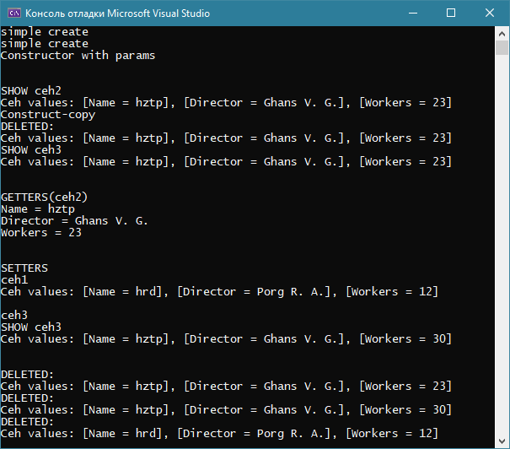
на С#
файл Ceh.cs
using System;
using System.Collections.Generic;
using System.Linq;
using System.Text;
using System.Threading.Tasks;

namespace laba1
{
class Ceh
{
private string name;
private string director;
private int workers;

public Ceh()
{
Console.WriteLine("Simple create");
}
public Ceh(string name, string director, int workers)
{
Console.WriteLine("Construct with params");
this.name = name;
this.director = director;
this.workers = workers;
}

public Ceh(Ceh ceh)
{
Console.WriteLine("Construct-copy");
this.name = ceh.name;
this.director = ceh.director;
this.workers = ceh.workers;
}
~Ceh()
{
Console.WriteLine("DELETED: ");
this.showAllParams();
}

public string getName()
{
return this.name;
}
public string getDirector()
{
return this.director;
}
public int getWorkersCount()
{
return this.workers;
}

public void setName(string name)
{
this.name = name;
}
public void setDirector(string director)
{
this.director = director;
}
public void setWorkerCount(int count)
{
this.workers = count;
}

public void showAllParams()
{
Console.WriteLine("Ceh value:");
Console.WriteLine(String.Format("[Name = {0}, Director = {1}, Workers = {2}]", this.name, this.director, this.workers));
}

}
}
файл Program.cs
using System;
using System.Collections.Generic;
using System.Linq;
using System.Text;
using System.Threading.Tasks;

namespace laba1
{
class Program
{
static void Main(string[] args)
{
Ceh ceh1 = new Ceh(), ceh3;
Ceh ceh2 = new Ceh("hztp", "Ghans V. G.", 23);

space();
Console.WriteLine("SHOW ceh2");
ceh2.showAllParams();
ceh3 = new Ceh(ceh2);
Console.WriteLine("SHOW ceh3");
ceh3.showAllParams();

space();
Console.WriteLine("GETTERS(ceh2)");
Console.WriteLine(String.Format("Name = {0}\nDirector = {1}\nWorkers = {2}", ceh2.getName(), ceh2.getDirector(), ceh2.getWorkersCount()));

space();
Console.WriteLine("SETTERS");
Console.WriteLine("ceh1");
ceh1.setName("hrd");
ceh1.setDirector("Porg R. A.");
ceh1.setWorkerCount(12);
ceh1.showAllParams();

Console.WriteLine("\nceh3");
ceh3.setWorkerCount(30);
Console.WriteLine("SHOW ceh3");
ceh3.showAllParams();
space();

Console.ReadKey();
}

private static void space()
{
Console.Write("\n\n");
}
}
}

Результати:
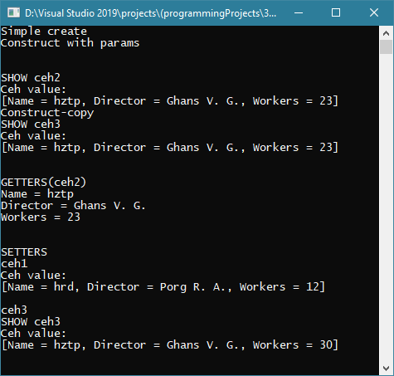

Завдання 2:

Висновок: на лабораторній отримали практичні навички реалізації класів на С++ та С#.

